Jenkins Pipelines
- Create one Declarative pipeline job
  - Source Code: https://github.com/betawins/spring3-mvc-maven-xml-hello-world-1.git
1. Create a Jenkins Pipeline job
- Open your Jenkins dashboard.
- Click New Item.
- Enter the job name: spring-mvc-pipeline
- Select Pipeline.
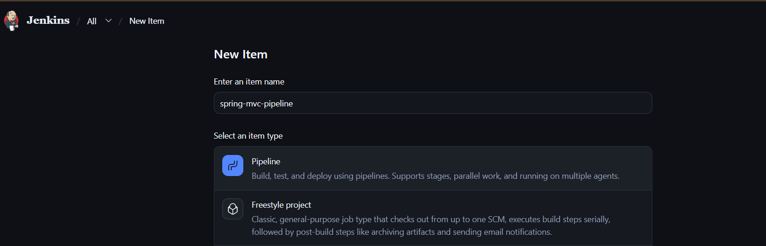
- Click OK.

Step 2: Configure the Pipeline
Scroll down to the Pipeline section and select these settings:
Setting | Value
Definition | Pipeline script from SCM
SCM | Git
Repository URL | https://github.com/betawins/spring3-mvc-maven-xml-hello-world-1.git
Branch Specifier | */master or your actual default branch
Script Path | Jenkinsfile
Step 3: Save and run
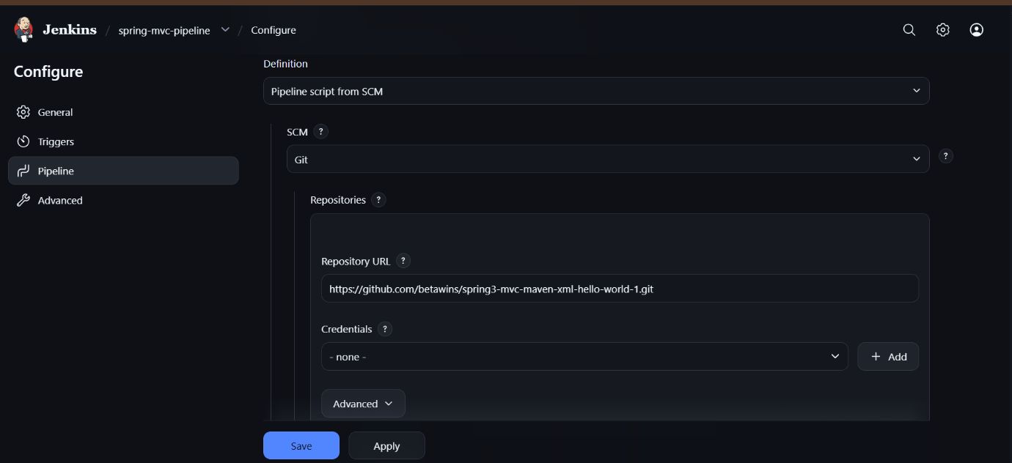
- Click Save.
- Click Build Now.
- Open the build number.
- Click Console Output to check the result.
Step 4: Verify
Jenkins will fetch the existing Jenkinsfile from GitHub and execute the pipeline defined inside it.
Important: If the build fails, share the existing Jenkinsfile or the Console Output error. We can fix the configuration without creating a new file.
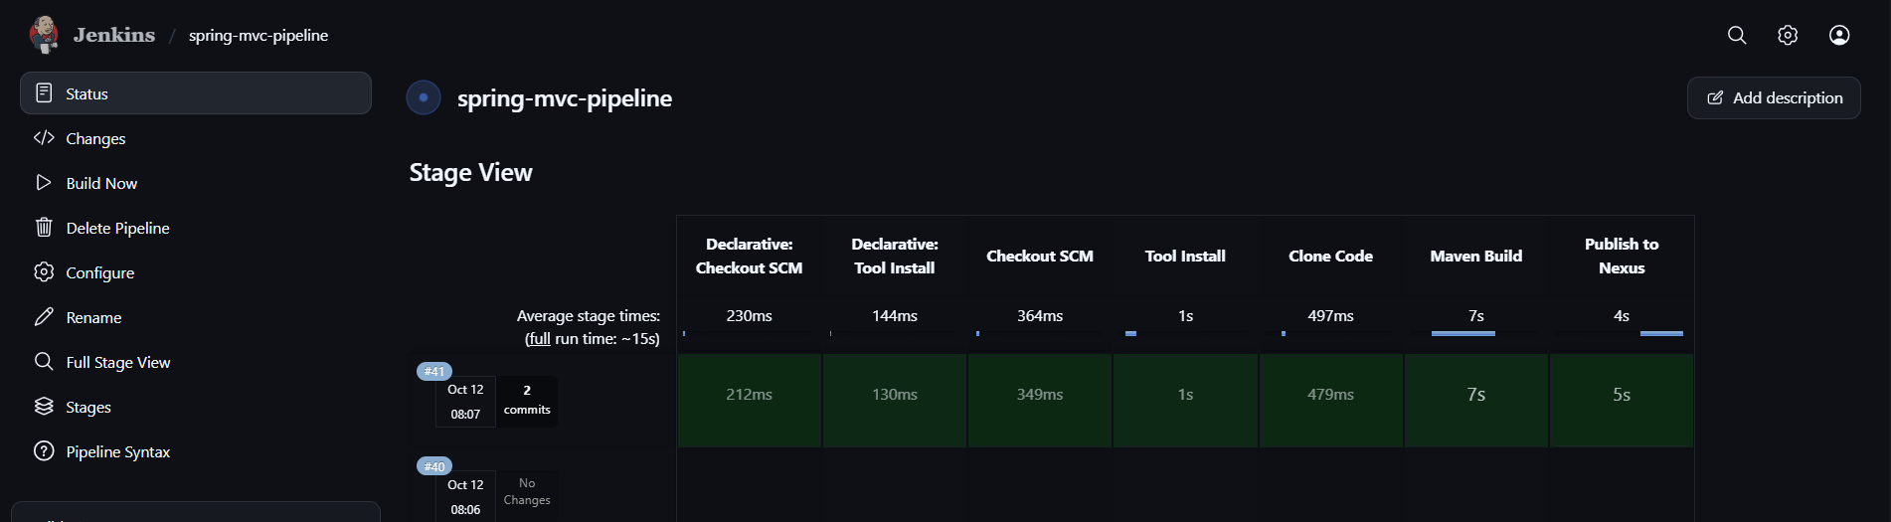

- Create one Scripted pipeline job
  - Source Code: https://github.com/betawins/spring3-mvc-maven-xml-hello-world-1.git
Step 1: Create a Jenkins job
- Open Jenkins: http://18.212.239.49:8080
- Click New Item.
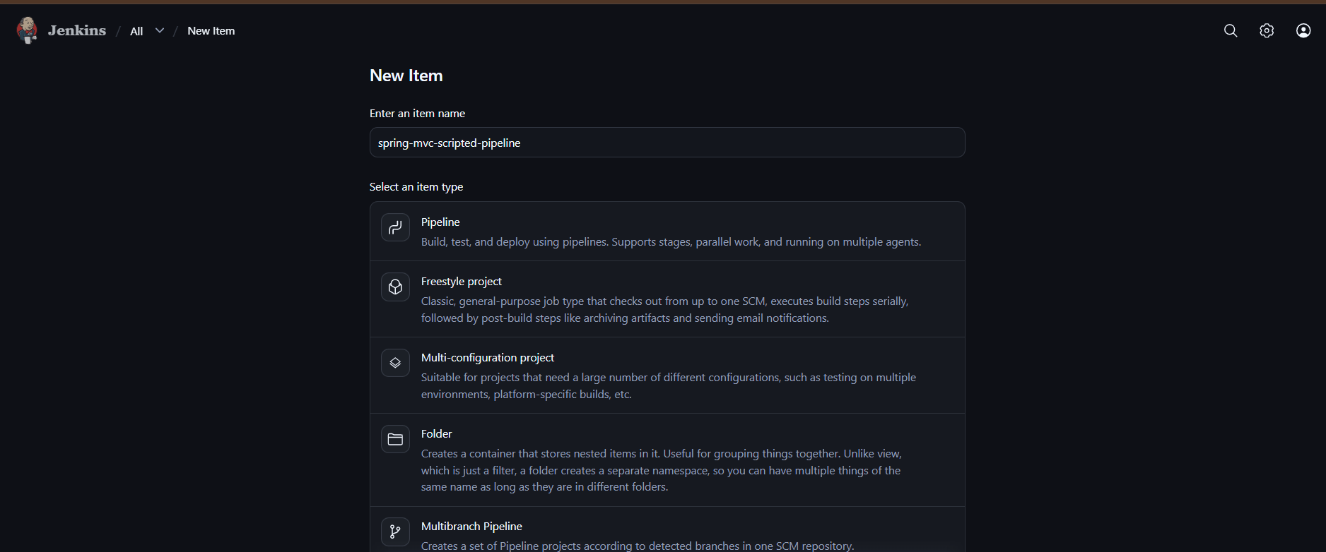
- Enter job name: spring-mvc-scripted-pipeline
- Select Pipeline → click OK.
- Scroll down to the Pipeline section.
- Set Definition to Pipeline script.
- Paste the script below.
Step 2: Scripted Pipeline code

node {
stage('Checkout SCM') {
git 'https://github.com/betawins/spring3-mvc-maven-xml-hello-world-1.git'
}

stage('Tool Install') {
sh 'mvn -version'
sh 'java -version'
}

stage('Clone Code') {
echo 'Source code checked out successfully'
sh 'ls -la'
}

stage('Maven Build') {
sh 'mvn clean package'
}
}
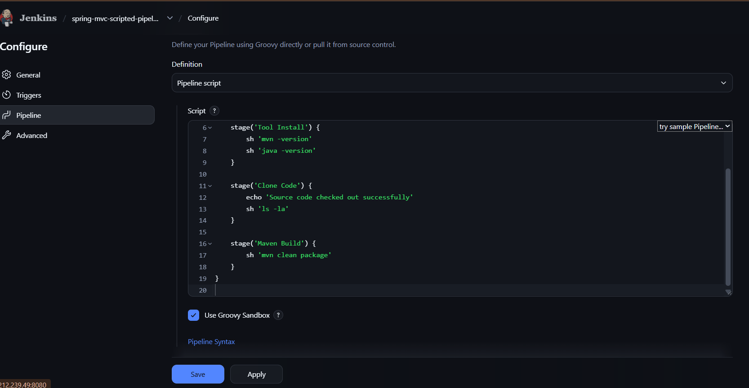
Step 3: Save and run
- Click Save.
- Click Build Now.
- Open Console Output to check the result.
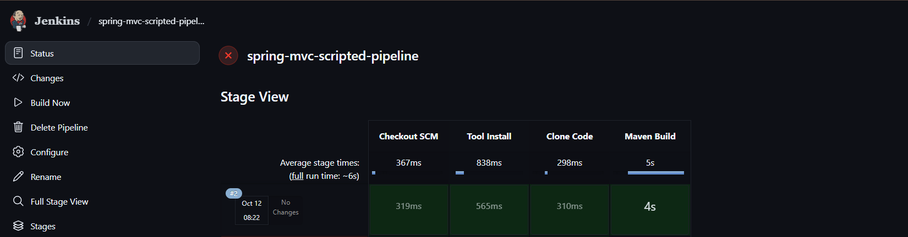
Note: This script assumes Maven and Java are already available on the Jenkins agent. Unlike Declarative Pipeline, Scripted Pipeline uses node {} and does not use the pipeline {} block.
If the build succeeds, your Scripted Pipeline job is complete.

- Create one Parameterized job
  - Source Code: https://github.com/betawins/spring3-mvc-maven-xml-hello-world-1.git
Step 1: Create a new job
- Open Jenkins: http://18.212.239.49:8080
- Click New Item.
- Enter name: spring-mvc-parameterized-pipeline
- Select Pipeline and click OK.
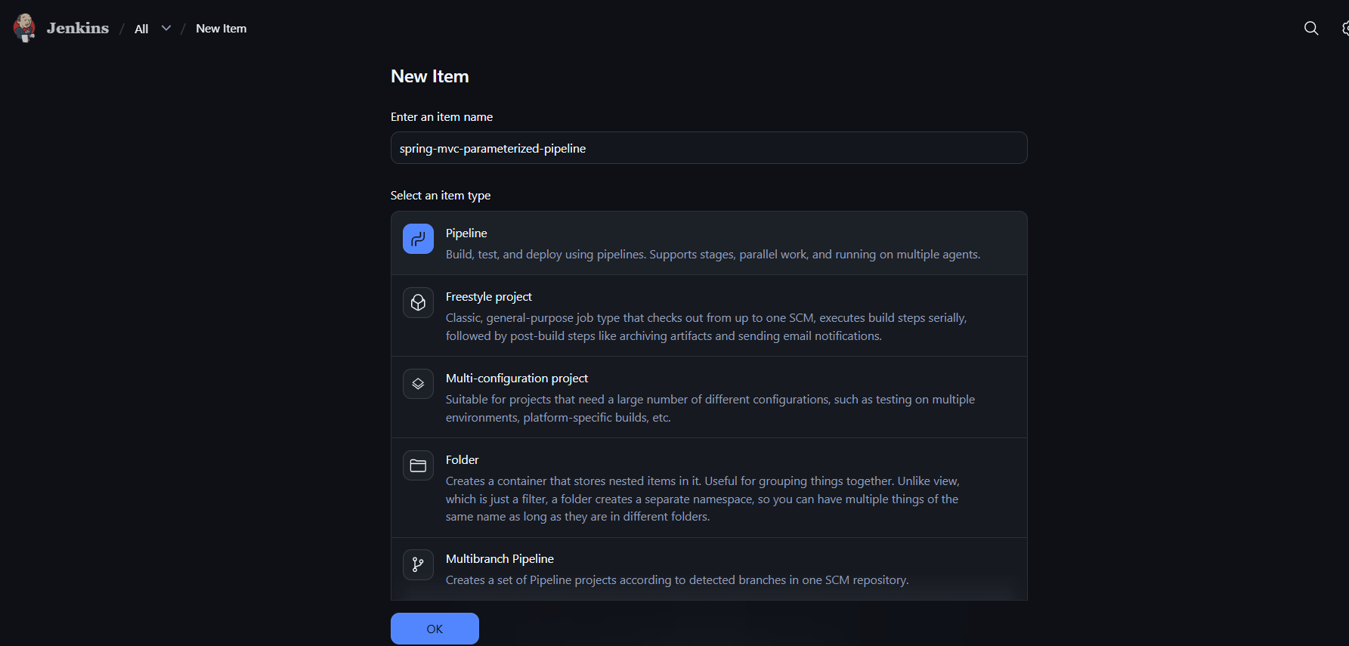
Step 2: Add a parameter
Under General, select This project is parameterized.
Add a String Parameter:
- Name: GIT_BRANCH
- Default Value: main
- Description: Git branch to build
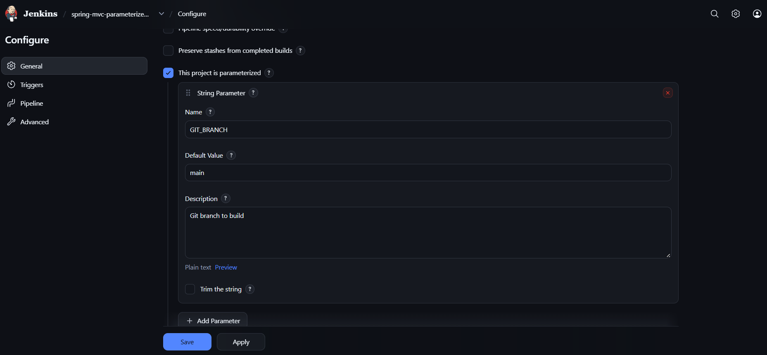
Step 3: Add the Pipeline script
Scroll to the Pipeline section, select Pipeline script, and paste this code.

node {
properties([
parameters([
string(
name: 'GIT_BRANCH',
defaultValue: 'main',
description: 'Git branch to build'
)
])
])

stage('Checkout SCM') {
git branch: "${params.GIT_BRANCH}",
url: 'https://github.com/satishcloud00/spring3-mvc-maven-xml-hello-world-1.git'
}

stage('Tool Check') {
sh 'mvn -version'
sh 'java -version'
}

stage('Maven Build') {
sh 'mvn clean package'
}
}
This uses your satishcloud00 repository, assuming that's the repository you used for Task 1 and Task 2.
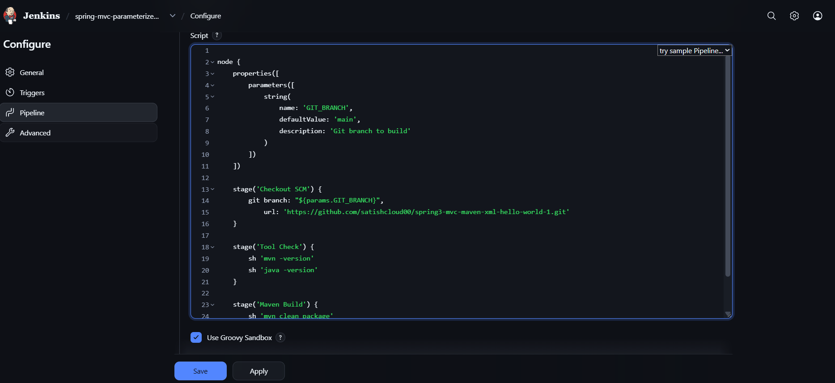
Step 4: Save and run
- Click Save.
- Click Build with Parameters.
- Keep GIT_BRANCH as main.
- Click Build
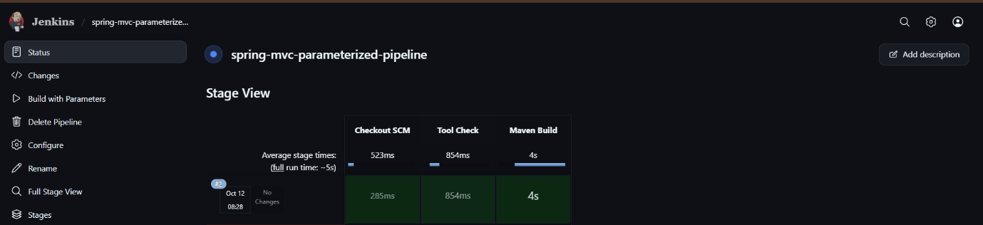
What makes it parameterized? You can choose the Git branch before starting the build, rather than hardcoding the branch in the pipeline.

- Write sample skeleton for Declarative and Scripted pipelines
1. Declarative Pipeline
Uses pipeline {} and a predefined structure.

pipeline {
agent any

stages {
stage('Build') {
steps {
echo 'Building application'
}
}

stage('Test') {
steps {
echo 'Testing application'
}
}

stage('Deploy') {
steps {
echo 'Deploying application'
}
}
}
}
2. Scripted Pipeline
Uses node {} and Groovy scripting.

node {
stage('Build') {
echo 'Building application'
}

stage('Test') {
echo 'Testing application'
}

stage('Deploy') {
echo 'Deploying application'
}
}

Key differences
Declarative | Scripted
Starts with pipeline {} | Starts with node {}
Uses stages and steps blocks | Uses stage blocks directly
Structured and easier to learn | More flexible with Groovy
Has built-in syntax validation | Requires more scripting knowledge

- Create one Declarative job
  - Source Code: https://github.com/betawins/sabear_simplecutomerapp/tree/feature-1.1
Step 1: Create the Jenkins job
- Open Jenkins: http://18.212.239.49:8080
- Click New Item.
- Enter job name: sabear-customerapp-declarative
- Select Pipeline → click OK.
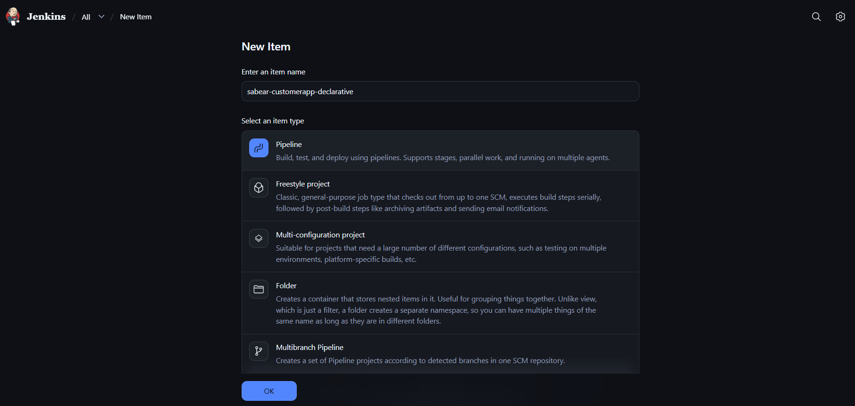
- Under Pipeline, select Pipeline script.

Step 2: Paste this Declarative Pipeline

pipeline {
agent any

stages {
stage('Checkout SCM') {
steps {
git branch: 'feature-1.1',
url: 'https://github.com/betawins/sabear_simplecutomerapp.git'
}
}

stage('Check Files') {
steps {
echo 'Source code checked out successfully'
sh 'ls -la'
}
}

stage('Build') {
steps {
echo 'Build stage started'
sh 'pwd'
}
}
}
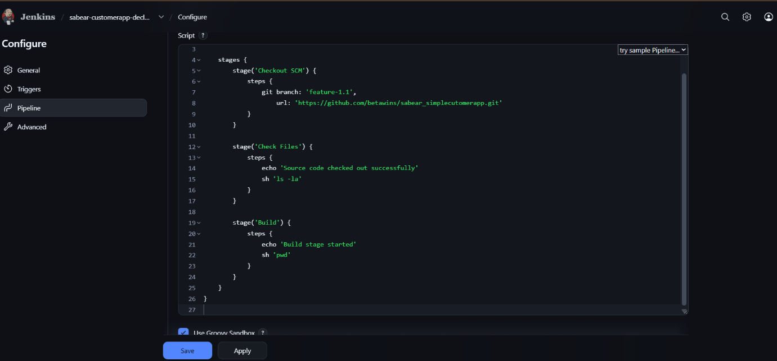
}

Step 3: Save and run
- Click Save.
- Click Build Now.
- Open Console Output
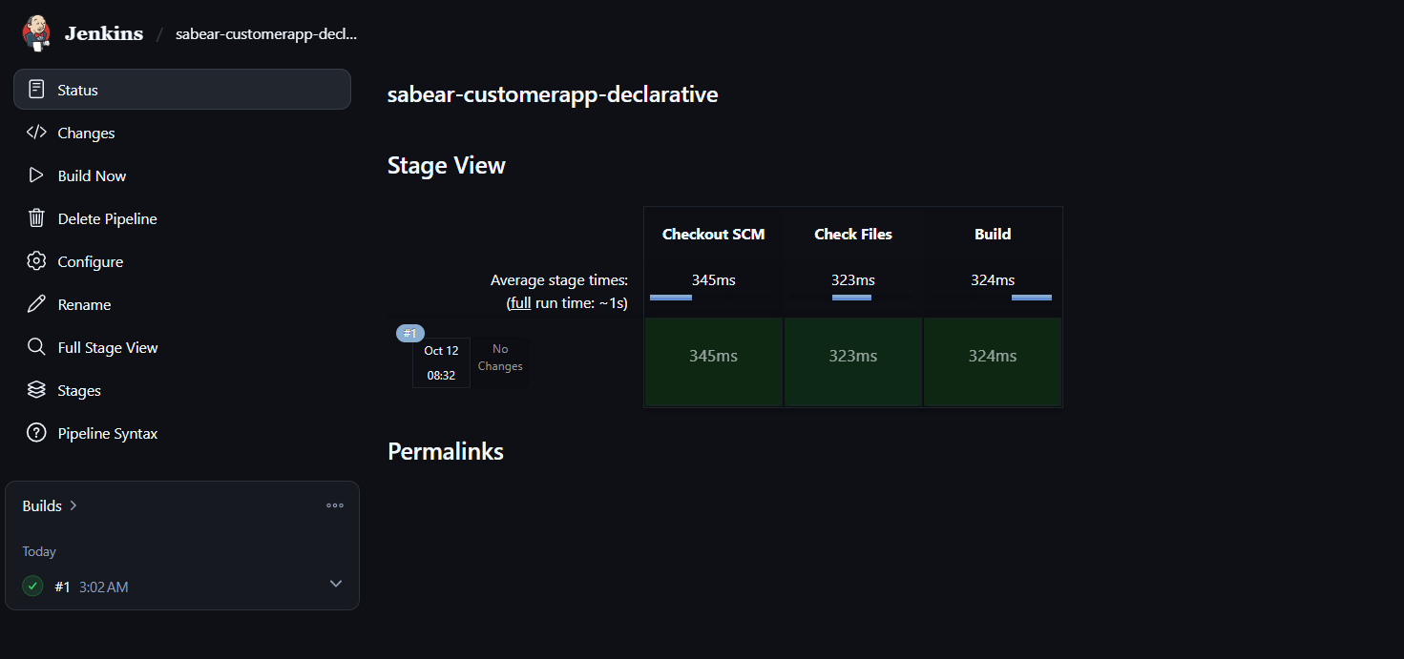
This pipeline checks out the feature-1.1 branch and lists the project files.
Note: This is a basic checkout-and-validation pipeline. Once we know the project's build tool and commands, we can add the actual build and test stages.

- Create one Declarative job
  - Source Code: https://github.com/betawins/Trading-UI.git
Step 1: Create a Jenkins job
- Open Jenkins: http://18.212.239.49:8080
- Click New Item.
- Job name: trading-ui-declarative
- Select Pipeline → click OK.
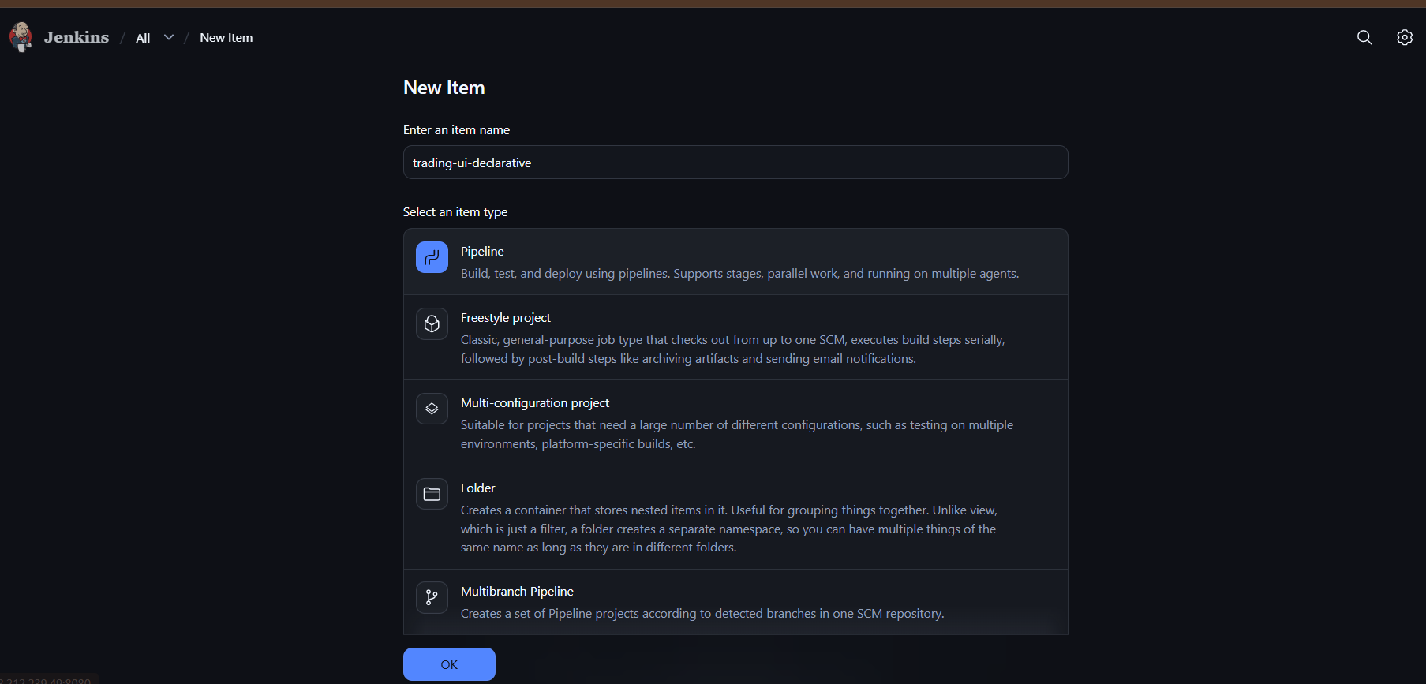
- Scroll down to the Pipeline section and select Pipeline script.
Step 2: Paste the Declarative Pipeline

pipeline {
agent any

stages {
stage('Checkout SCM') {
steps {
git 'https://github.com/betawins/Trading-UI.git'
}
}

stage('Check Files') {
steps {
echo 'Source code checked out successfully'
sh 'ls -la'
}
}

stage('Build') {
steps {
echo 'Build stage started'
sh 'pwd'
}
}
}

post {
success {
echo 'Pipeline completed successfully!'
}

failure {
echo 'Pipeline failed. Check Console Output.'
}
}
}

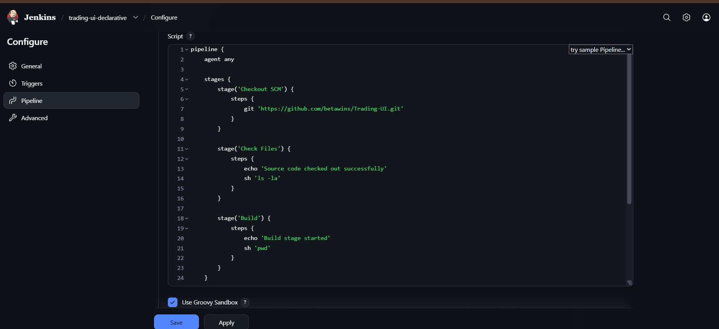
Step 3: Run the job
- Click Save.
- Click Build Now.
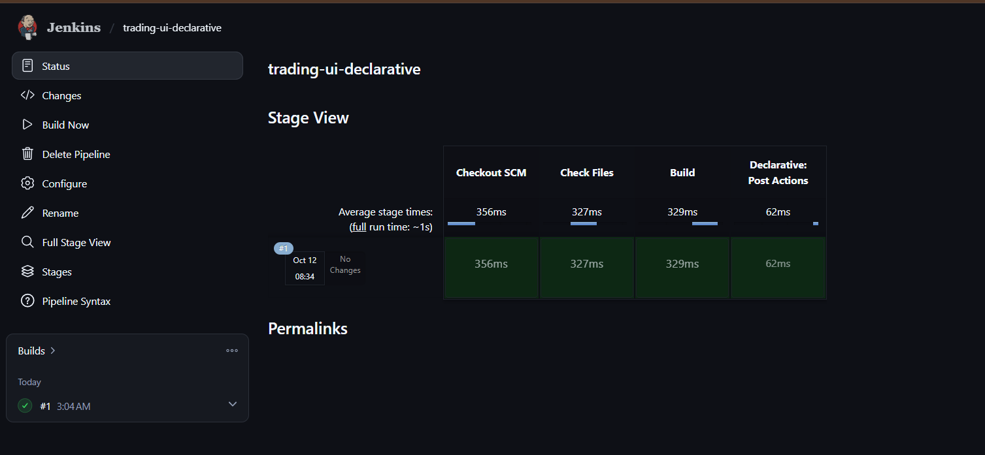
- Open Console Output to verify the result.

Note: This is a basic checkout pipeline. It doesn't compile or test the application yet. Once you confirm whether the repository uses React, Angular, or another framework, we can add the correct build and test commands.

- Execute parallel stages using Jenkins pipeline for any sample job
Step 1: Create a Jenkins job
- Click New Item.
- Enter name: parallel-stages-pipeline.
- Select Pipeline → click OK.
- Under Pipeline, select Pipeline script.
Step 2: Paste this pipeline

pipeline {
agent any

stages {
stage('Parallel Execution') {
parallel {
stage('Build') {
steps {
echo 'Building application...'
sh 'sleep 10'
echo 'Build completed'
}
}

stage('Test') {
steps {
echo 'Testing application...'
sh 'sleep 5'
echo 'Testing completed'
}
}

stage('Code Check') {
steps {
echo 'Checking source code...'
sh 'sleep 3'
echo 'Code check completed'
}
}
}
}
}

post {
success {
echo 'All parallel stages completed successfully!'
}

failure {
echo 'A parallel stage failed!'
}
}
}
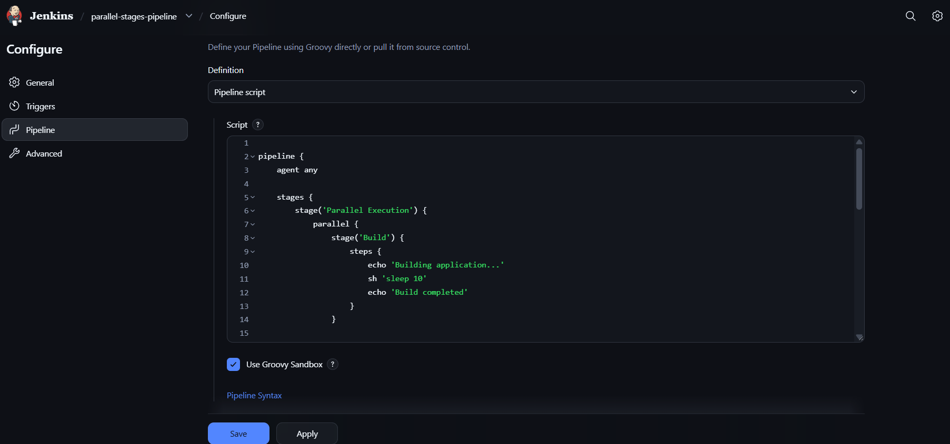
Step 3: Execute
- Click Save.
- Click Build Now.
- Open Stage View or Console Output.
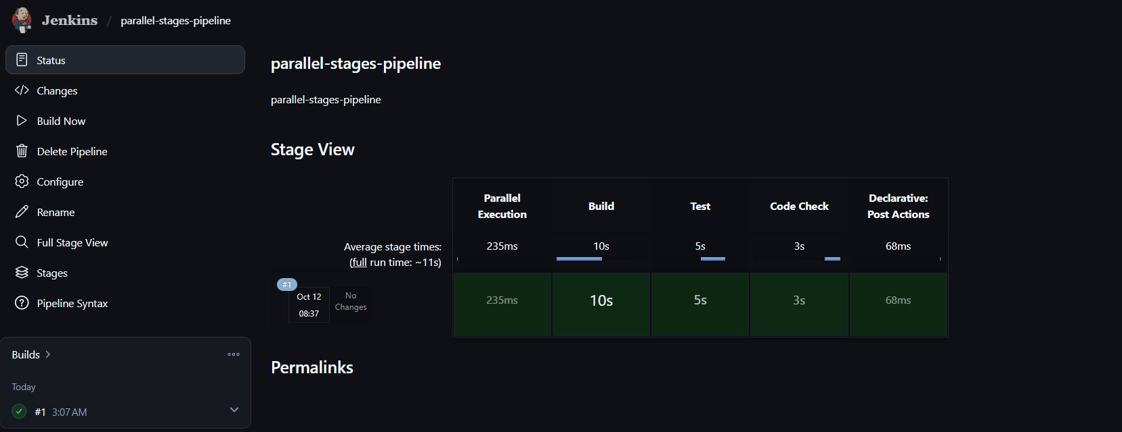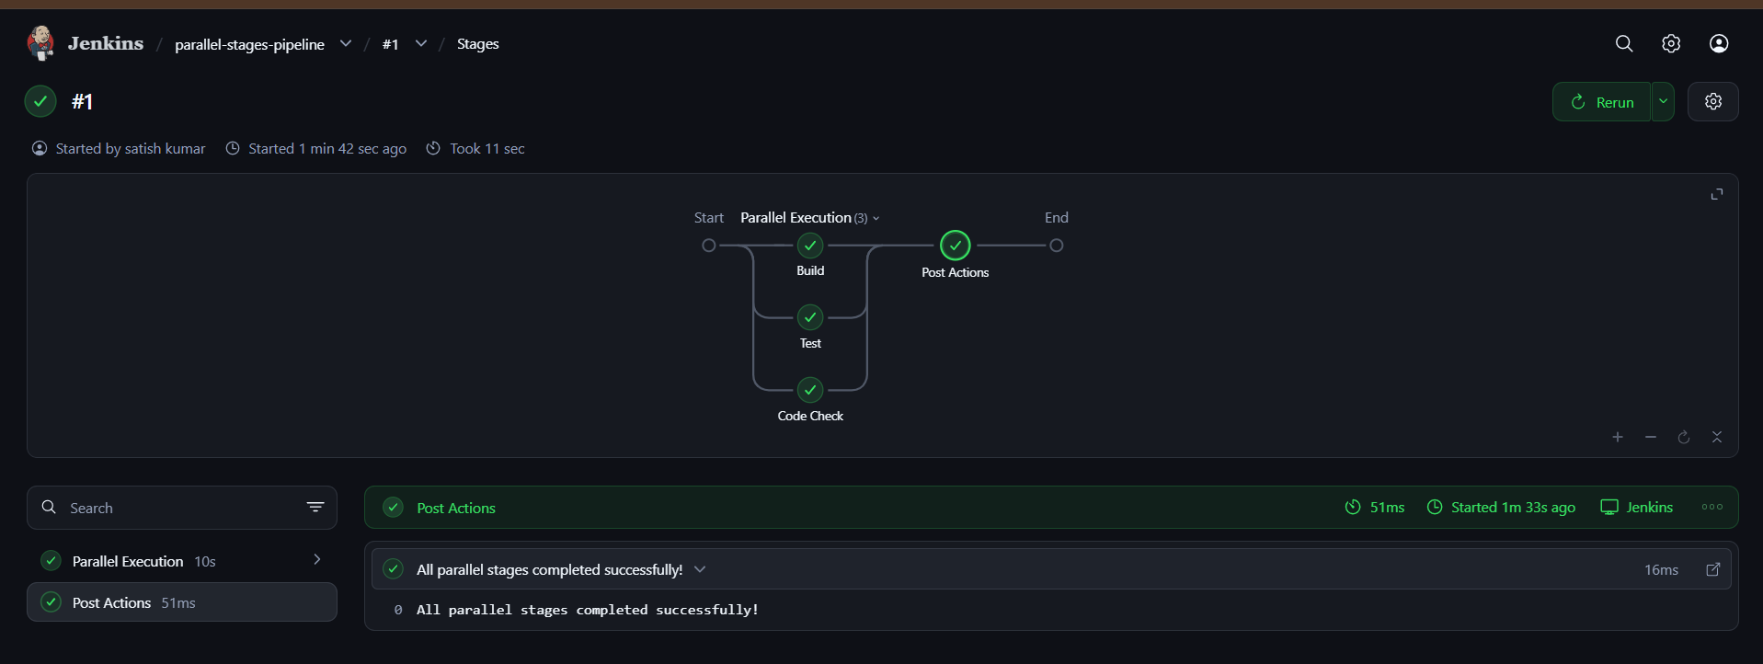

- Execute Jenkins pipeline stages using shared libraries
Reference: https://phoenixnap.com/kb/jenkins-shared-library
Step 1: Create a GitHub repository
- Open GitHub – Create new repository.
- Repository name: jenkins-shared-library
- Select Public.
- Click Create repository.
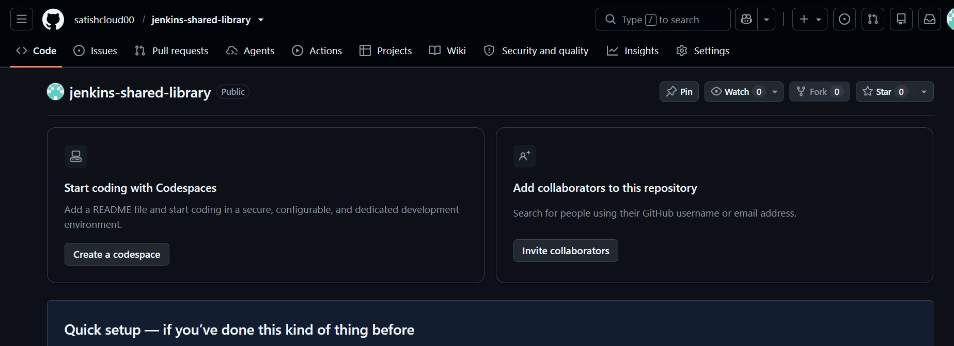
Step 2: Create the library file
In your new GitHub repository:
- Click Add file → Create new file.
- Enter the file name:
vars/helloPipeline.groovy
3. Paste this code:

def call() {
stage('Build') {
echo 'Building application'
}

stage('Test') {
echo 'Testing application'
}

stage('Deploy') {
echo 'Deploying application'
}
} 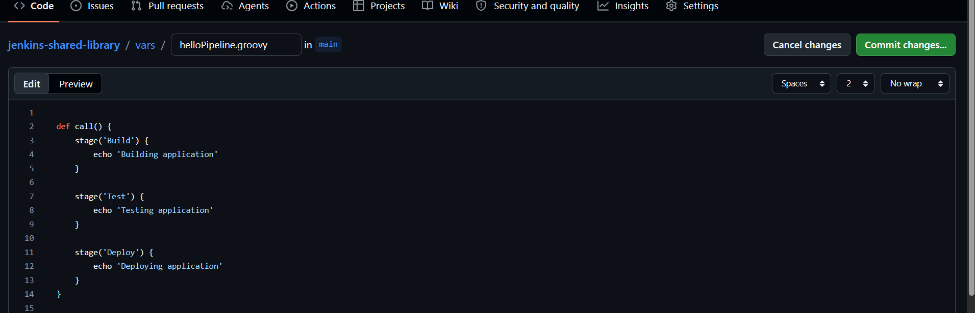
4. Click Commit changes.
Your repository should look like this:
jenkins-shared-library/
└── vars/
└── helloPipeline.groovy
Step 3: Configure the Shared Library in Jenkins
- Open Jenkins: http://18.212.239.49:8080
- Go to Manage Jenkins → System.
- Find Global Trusted Pipeline Libraries.
- Click Add.
Enter these values:
Field | Value
Name | jenkins-shared-library
Default version | main
Load implicitly | Leave unchecked
Retrieval method | Modern SCM
Source Code Management | Git
Project Repository | https://github.com/YOUR_USERNAME/jenkins-shared-library.git
Replace YOUR_USERNAME with your actual GitHub username.
Click Save.
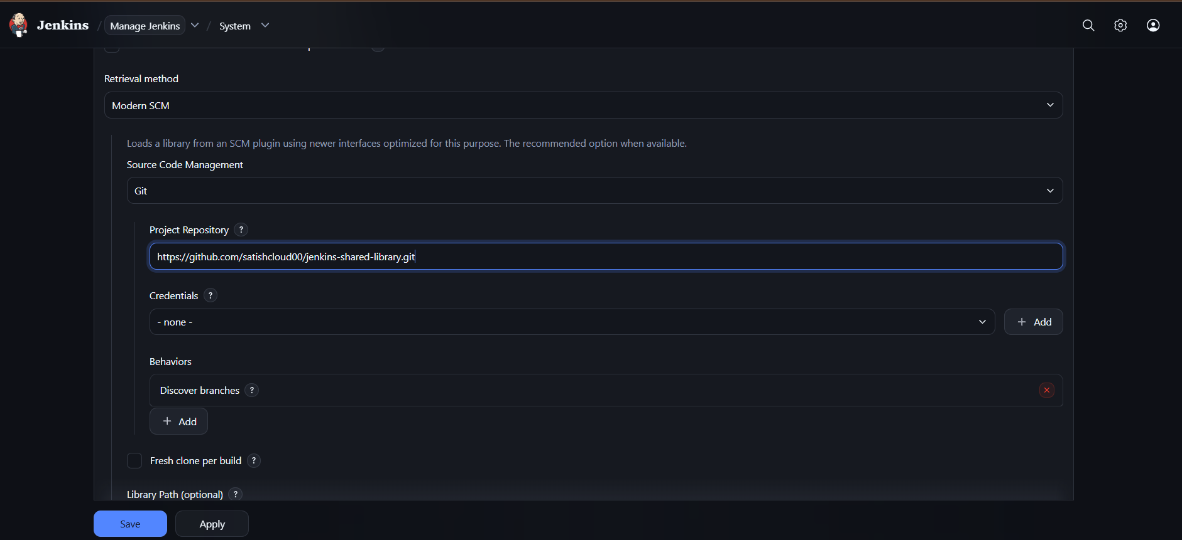
Step 4: Create a Jenkins Pipeline job
- Click New Item.
- Enter name: shared-library-demo.
- Select Pipeline.
- Click OK.
- Scroll to the Pipeline section.
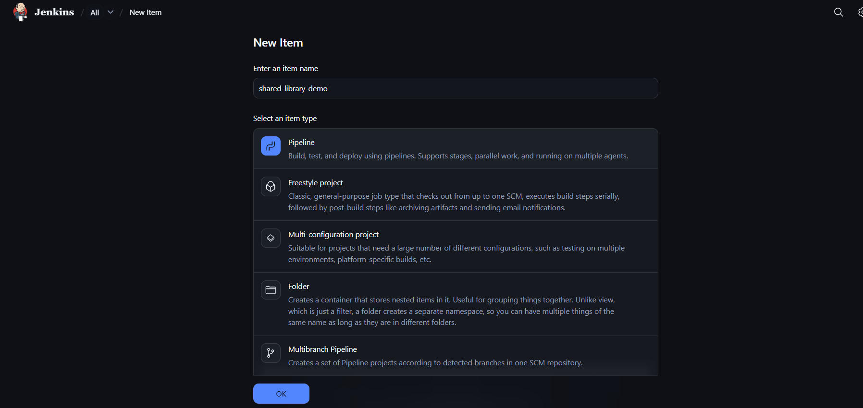
- Select Pipeline script.
Paste this code:

@Library('jenkins-shared-library') _

pipeline {
agent any

stages {
stage('Run Shared Library') {
steps {
script {
helloPipeline()
}
}
}
}
} 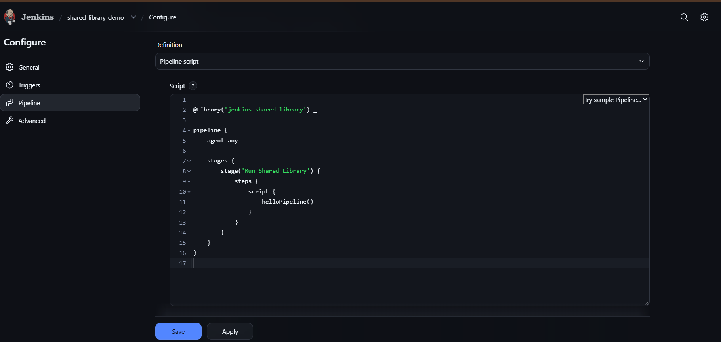
Click Save.
Step 5: Run the pipeline
- Click Build Now.
- Open Console Output.
Expected output:
Building application
Testing application
Deploying application
Finished: SUCCESS 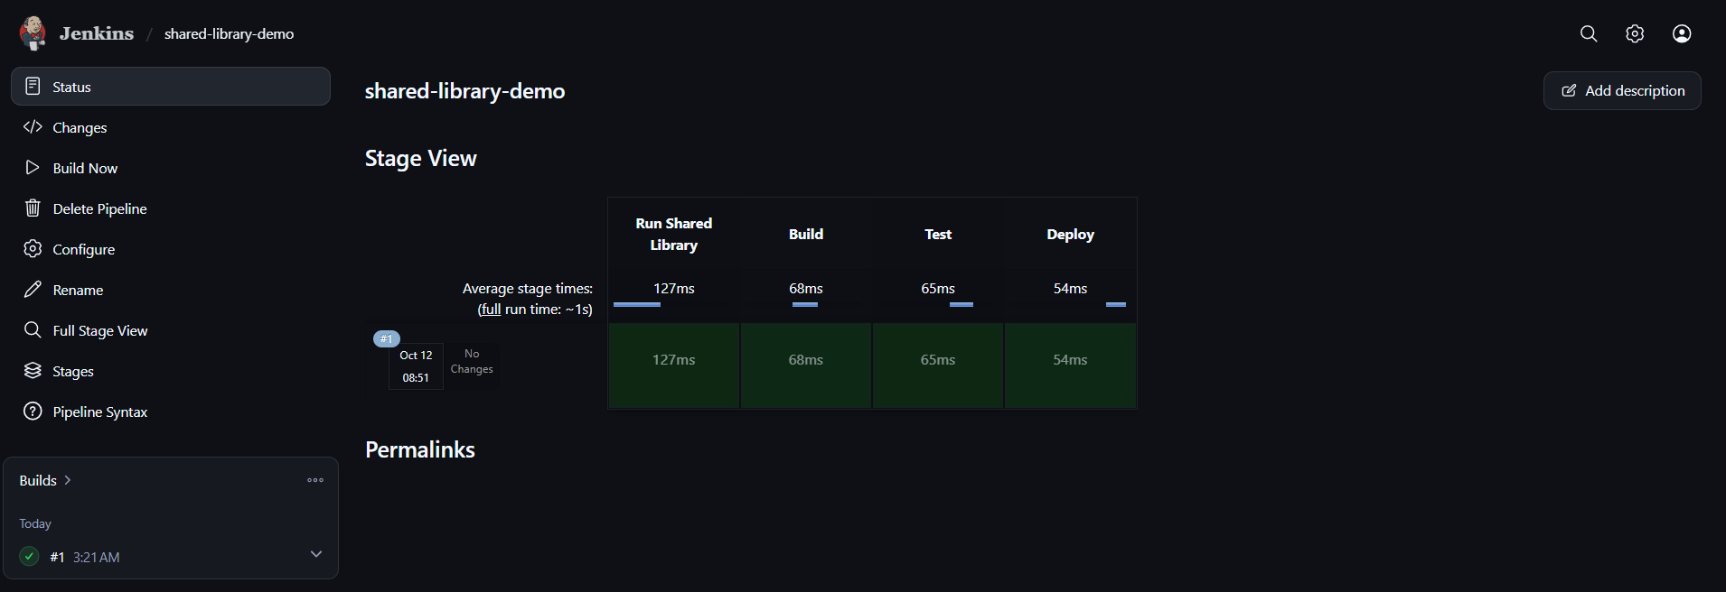
How it works
- helloPipeline.groovy contains reusable stages.
- @Library('jenkins-shared-library') _ loads the library.
- helloPipeline() calls the shared code.
Important: Replace YOUR_USERNAME with your real GitHub username before saving the library configuration.

